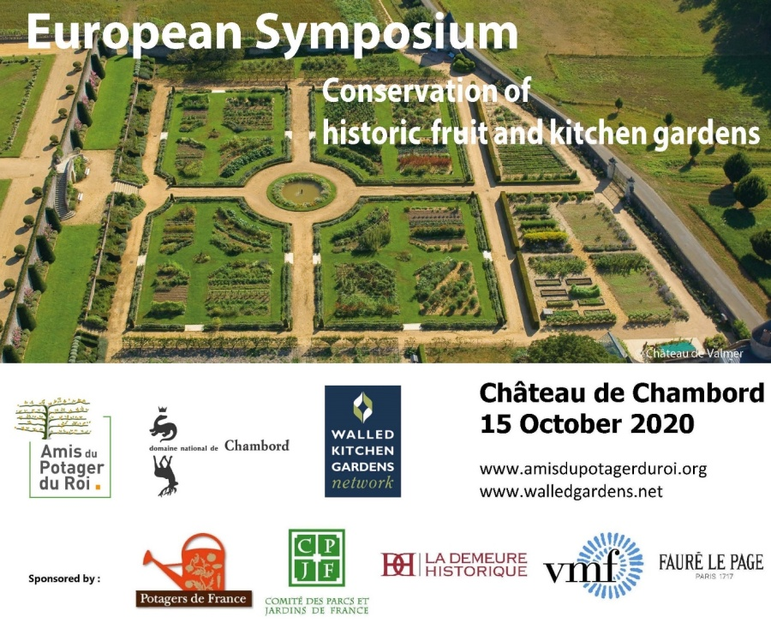
Registration Form

Registration essential as
places may become limited

4 online conferences and a final meeting in Chambord

The Symposium is free to attend, courtesy of the Domaine de Chambord

Thank you for registering for the Symposium: the Chambord Conversations a series of online talks and discussions
- 15 October 2020 ; 17 December 2020 ; 4 February 2021 ; 8 April 2021
- all from 9:30 am to 12 :00 (UK time) 10:30 - 13:00 (EU time)

The final meeting and conclusions will be held at Chambord in 2021, with optional visits the following day (dates to be arranged)

To register please return your completed form to :

lucypitman@virginmedia.com / 19 Bishopstrow, Warminster, Wiltshire BA12 9HN
amisdupotagerduroi@yahoo.fr / 11 rue du Maréchal Joffre 78000 Versailles

==========================================================================
Registration Form
European Symposium on the Conservation of historic Fruit and Kitchen Gardens
(New organisation)

Surname : ……………………… First name : ………………………

Email : ...............……………………………………………………………………...

Telephone : …………………………

Organisation : ………………………………………………………………………

Position/Profession : …………………………………………………………………

Address : ……………………………………………………………………………..

I would be interested in the day of optional visits following the final meeting in Chambord 2021

Date : … Signature :

