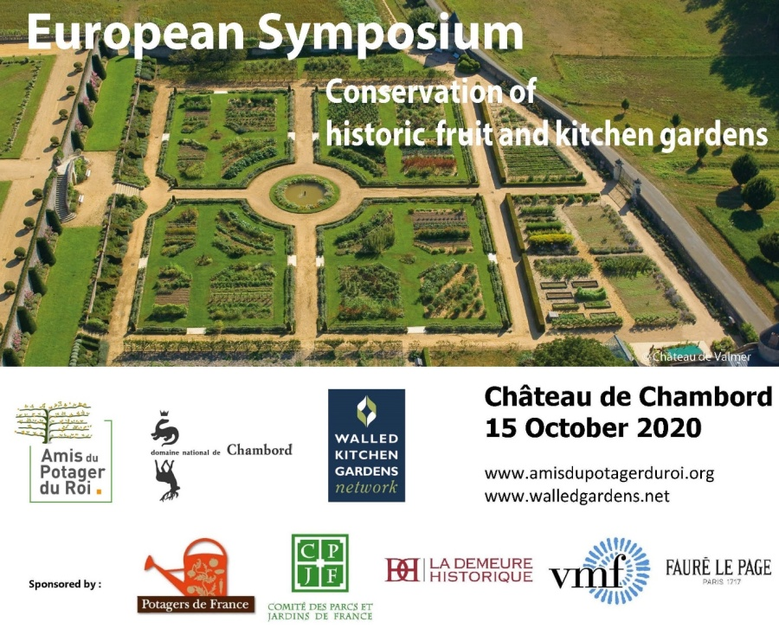
Registration Form

Registration essential as
places may become limited

A series of online conferences and final meeting in Chambord

The Symposium is free to attend, courtesy of the Domaine de Chambord

Thank you for registering for the Symposium: the Chambord Conversations a series of online talks and discussions
- 15 October 2020 ; 17 December 2020 ; 4 February 2021 ; 8 April 2021
additional dates : 17th June 2021 ; 21st October 2021 ; 3 February 2022

- all meetings from 9:30 am to 12 :00 (UK time) 10:30 - 13:00 (EU time)
- NOTE : change of time on 21st Oct. 2021 : 9:00-12:00 (UK) and 10:00-13 :00 (EU)

The final meeting and conclusions will be held at Chambord, 23rd June 2022, with optional visits the following day (all dates to be arranged)

To register please return your completed form to :

lucypitman@virginmedia.com / 19 Bishopstrow, Warminster, Wiltshire BA12 9HN
amisdupotagerduroi@yahoo.fr / 11 rue du Maréchal Joffre 78000 Versailles

==========================================================================
Registration Form
European Symposium on the Conservation of historic Fruit and Kitchen Gardens
(New organisation)

Surname : ………… First name : …………

Email : ..........…...

Telephone : …………………

Organisation : …… ………

Position/Profession : …

Address : ……… ……..

YES I would be interested in the day of visits following the final meeting in Chambord

Date : … Signature :

