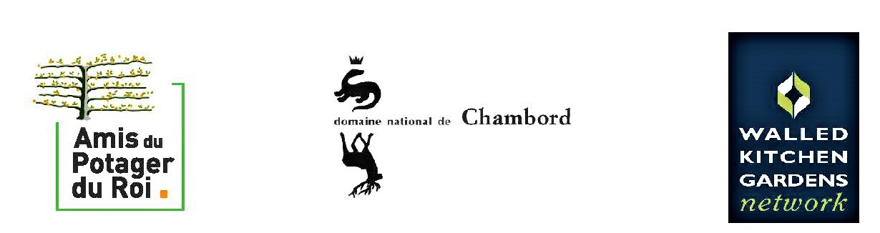

Registration Form
Closing session of the European Symposium / Optionalday of visits
23rdJune 2022 24thJune 2022

One form per person
amisdupotagerduroi@yahoo.fr

Your registration withbedependant on receipt of payment by banktransfer,
to Association des Amis du Potager du Roi

Surname :First name:
Organisation (will appear on your badge) :
Email :

23rdJune 2022, Château de Chambord
Courtesy of the Domaine de Chambord, participation at the Symposium is free.
Only the cost for food¹, refreshments and documentation of 40 € willbe payable by participants.

To help us with the organisation of workshops,pleasecanyou tell us the languagesmostappropriate to you:

Language | French | English | Dutch
First language or I am fluent in:
I understand well
I understand a little
I don’tunderstand
Call for contributions :

As well as the workshops to beorganised ; in whatsubject(s) in order 1-7 – subjects 1-7 of the workshops or anothersubject(see programme) – wouldlike to make a contribution ?

24rdJune 2022, Optional day of visits :
Château de Villandry, Château de La Bourdaisière, Château de Valmer
Thanks to the generosity of our hosts, only lunch will requirepayment by participants,€35 per person

Participants are responsible for theirown transport

The winetastingat Château de Valmerisoffered in addition to the event

Symposium | € 40
Optionalvisits | € 35
FINAL TOTAL

Payment by banktransfer to :
Association des Amis du Potager du Roi :
IBAN : FR76 1820 6003 6765 0325 8428 988 / BIC : AGRIFRPP882

