Historic Fruit and Kitchen Gardens
Newsletter number 2, March 2023

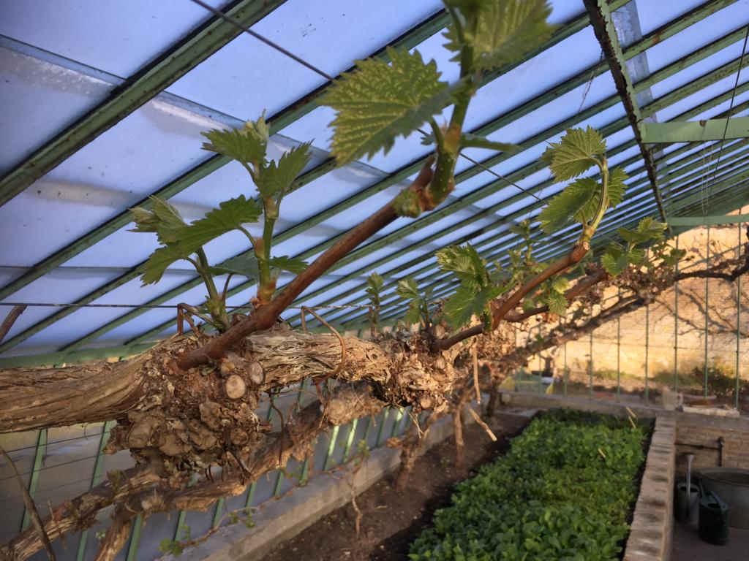
©Jelle Reeder
________________________________________

Recording online conference February 23, 2023
We started our new series of webinars with a wonderful presentation on the restoration of the Zuylestein kitchen garden in The Netherlands and some thought provoking presentations by headgardeners on the effects of climate change on gardens. If you missed it, do not worry. This time all presentations have been recorded. You can find them on our website. Or you can use these links:
https://youtu.be/_WvqbsKzJDg : Rob Plomp and Hennes Claassen
https://youtu.be/mKU-ND6EhRs : Julien Billon
https://youtu.be/6mQFF2YROCM : Kelly Fowler and Gemma Sturges
https://youtu.be/PYhuFQzHncs : Alix de Saint Venant and René Dessing
https://youtu.be/uh2h1k9awHQ : Jemima de Brauwere

Save the date: next online conference June 8, 2023
Our next online conference will be June 8, 2023, 10.00 – 12.00 a.m. (9.00-11.00 GMT). The topic is the history and conservation of some exceptional historical fruit trees.
Hilary Theaker (Hampton Court) will present the Hampton Court Kitchen Garden (UK) and the history of its 200-year old vine and how they take care of this vine to conserve it.
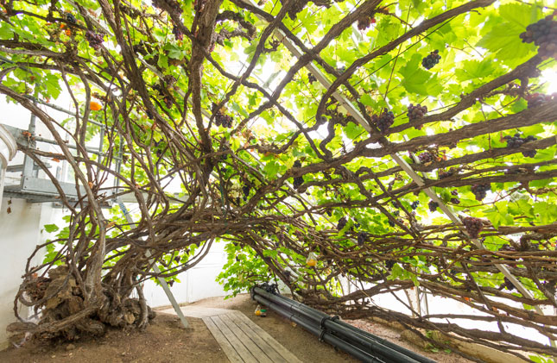
©Historic Royal Palaces
Sébastien Conil and Stefan Vidts (Freÿr) will present the Freÿr garden (Belgium) and how they have been able to conserve and continue to conserve 300-year old orange trees. These are probably some of the oldest orange trees kept in cases in the world.
Please join in!
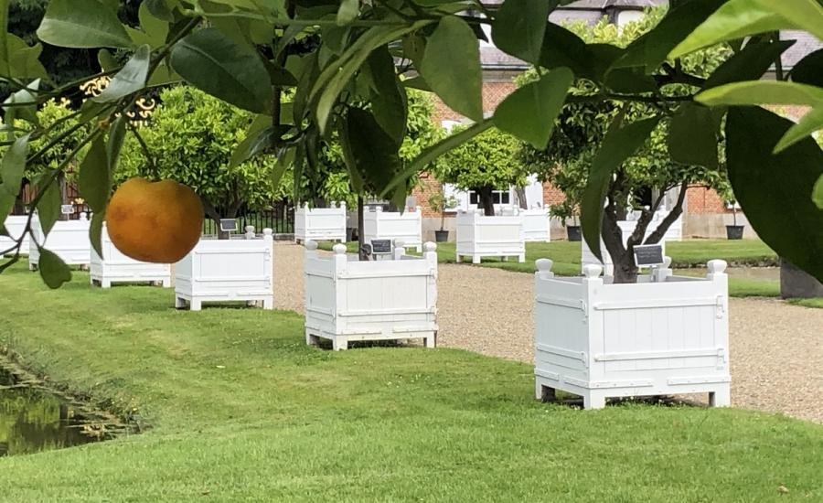
©chateau Freÿr
Susan Campbell awarded Veitch Memorial Medal 2023
We are delighted to announce that Susan Campbell has been awarded the prestigious RHS Veitch Memorial Medal 2023. Given for outstanding contribution to the advancement of the science and practice of horticulture, for Susan in recognition of her astonishing years of work and research on walled kitchen gardens - writer, historian, artist and gardener. We wish Susan huge congratulations!
Susan Campbell

A long standing tradition revived
While the symposium aims to revive the old custom of gardeners exchanging their expertise among their peers, Lenneke Berkhout has published a book, Hoveniers en Tuinbazen, about the exchanges between Dutch and foreign gardeners over the centuries. British gardeners have certainly benefited from this exchange!
Susan Campbell
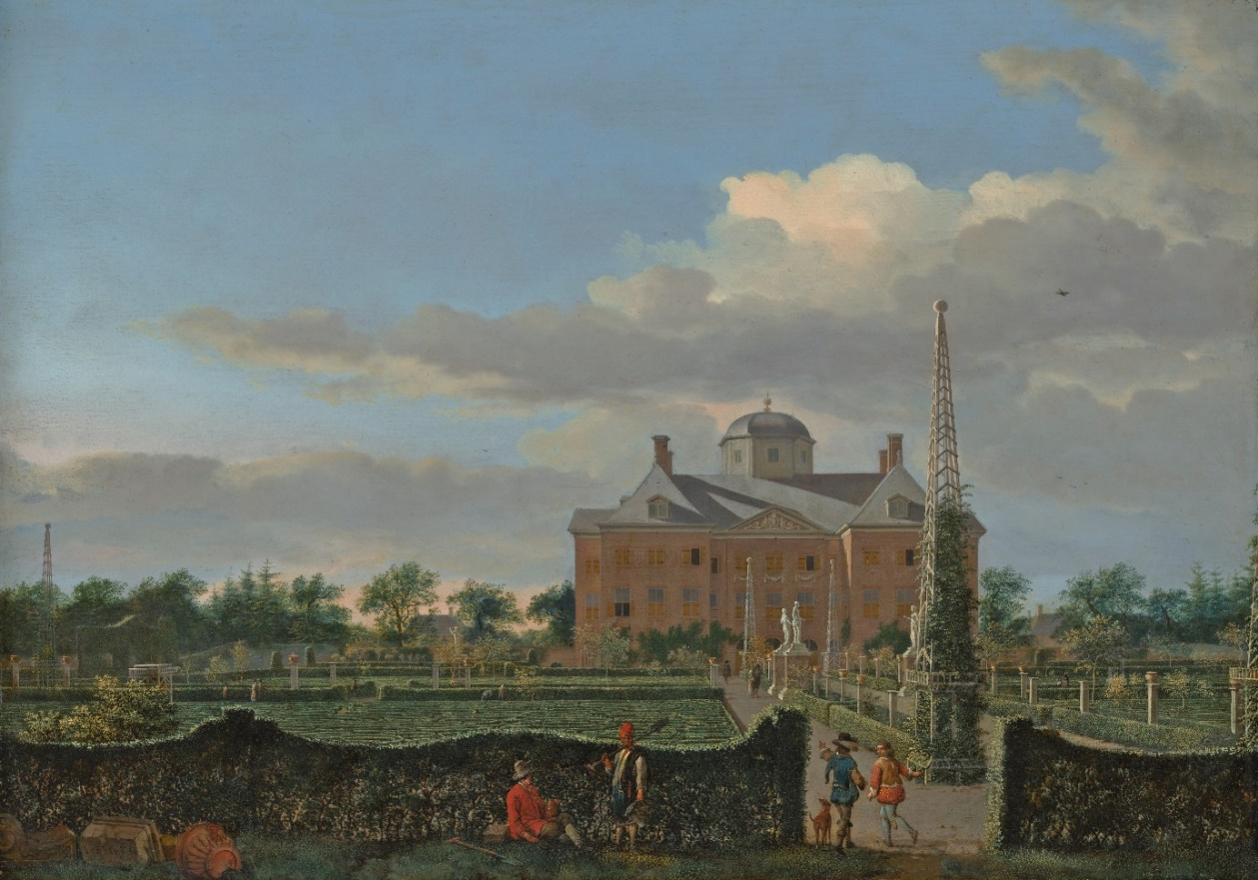
Head gardener in red livery talking to one of his undergardeners in the gardens of Huis ten Bosch near The Hague (Jan van der Heyden, 1668-1670, The Metropolitan Museum of Art New York).

In the seventeenth and early eighteenth century Dutch gardeners brought their knowledge and experience to Sweden and Russia. German, Russian and Swedish journeymen came to Holland to finish their education. In turn gardeners from France and England were recruited to pass on specific skills to Dutch gardeners. German gardeners were employed to maintain gardens especially in Friesland in the northern part of the Dutch Republic. Exchanging knowledge and experience across borders was highly valued and has been a long standing tradition amongst gardeners.
Need for skilful gardeners
From the second half of the seventeenth through to the early eighteenth century Dutch gardening flourished. Key to this flourishing was the ambition of the House of Orange-Nassau to be part of the international network of European nobility. They built richly decorated palaces and gardens. The laying and upkeep of these gardens required skilful head gardeners. These head gardeners were literate men, who had a broad base of horticultural knowledge and skills.
In Paris the guild of maîtres jardiniers set standards for the qualifications of gardeners, as did the Worshipful Company of Gardeners in London. The Dutch Republic did not have such guilds of head gardeners. However, by passing on the craft of gardening from father to son and from head gardener to apprentice the example of the guilds was followed. Besides, head gardeners exchanged experience amongst themselves and they also acquired knowledge through books.

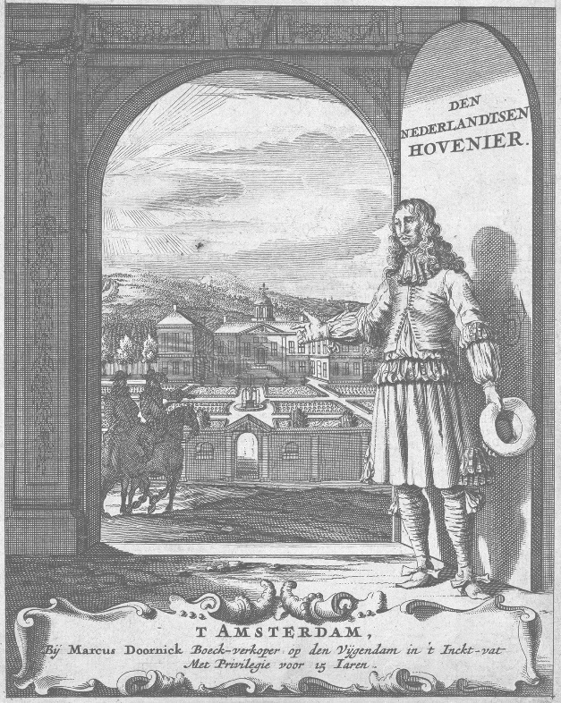
The Dutch Gardener, a treatise written in 1669 by Jan van der Groen, head gardener to the Prince of Orange.
Across borders
William III, prince of Orange, was well aware of new developments in horticulture and he wanted the latest techniques to be used in his gardens. He recruited gardeners from France and England to teach their Dutch colleagues specific new skills that were yet unknown to them. In 1675 French gardener Charles du Buisson, who may have worked at Versailles, came to Holland and was made head gardener of the prestigious princely gardens at Honselaarsdijk palace. Besides maintaining these gardens he was assigned to teach the gardeners in all the princely gardens how to prune the newly acquired dwarf trees (arbres nains). Du Buisson’s contract stated explicitly that other gardeners were not allowed to prune these dwarf trees unless Du Buisson was around.
William III was also quite impressed with English lawns. He employed English undergardener Ralph Mose at the gardens of Loo Palace to raise the quality of the lawns to English standards.
In their turn Dutch gardeners shared their knowledge with German, Swedish and Russian journeymen who came to Holland to finish their education as a gardener. The gardens at Honselaarsdijk palace seem to have been an educational center, drawing in many journeymen form other parts of Holland and from abroad.

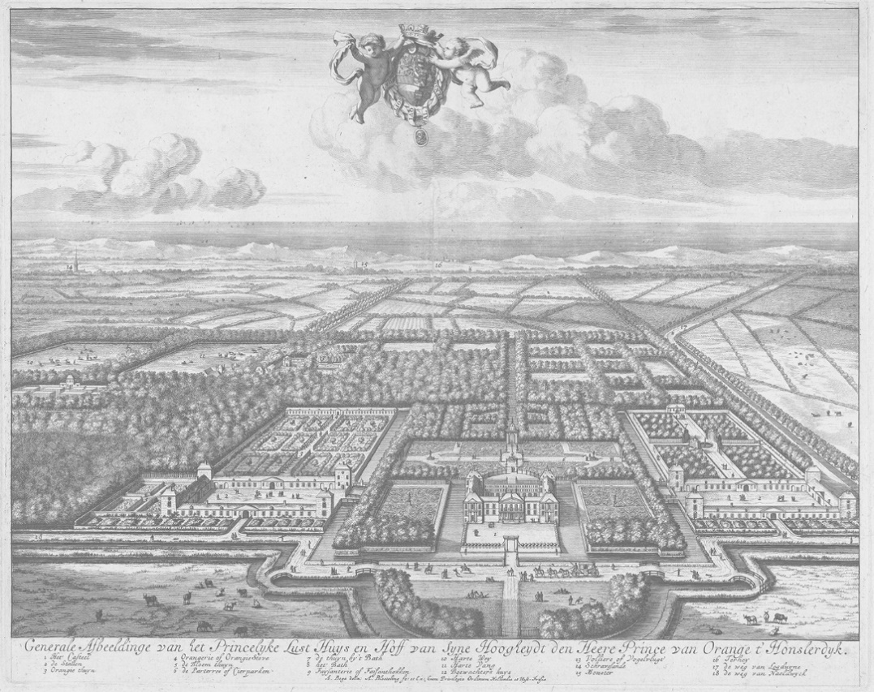
Abraham Bloteling naar Abraham Jansz. Begeyn, Gezicht op Honselaarsdijk in vogelvlucht, 1684-1690, Rijksmuseum Amsterdam.

Dutch gardeners also moved to other countries. William III brought along some of his Dutch gardeners to England, when he was made king of England in 1689. Both Hendrik Quellenburg, head gardener of the Privy Garden at Hampton Court, and his son-in-law Samuel van Staden, who was responsible for maintaining the Wilderness at Hampton Court, had worked as head gardener at princely gardens in The Dutch Republic.
Samuel’s brother, Jan van Staden travelled even further. He had made a career designing and creating gardens for owners of country houses and estates in Holland. Like some other Dutch gardeners before him, Jan was offered a three-year contract in 1719 to work as a supervisor of the Summergarden in Saint Petersburg. Czar Peter the Great rewarded him generously and granted him an apartment and an interpreter. Jan’s stay did not turn out to be a success however. He was good at his work, but he managed to get into conflict with almost everybody including the czar himself. When his contract was not renewed in 1721, he was infuriated and left Saint Petersburg with the very first ship that sailed for Holland (he did ask the Dutch ambassador in Saint Petersburg to forward his remaining salary!).
Quite a number of German gardeners moved to the Dutch Republic in the early eighteenth century, especially to the northern province of Friesland. They were most welcome at the court of the princess Maria Louise of Hesse-Kassel, who was German by birth and had moved to Friesland on account of her marriage. Famous gardeners like Johann Hermann Knoop and the Semler family were employed by her.

An old tradition revived
So, the European webinars and conference on the conservation of historic fruit and kitchen gardens stand in a long tradition of exchanging knowledge and skills. And it is wonderful we are giving this exchange across borders a new boost by discussing all kinds of topics and sharing experiences.

Please let us know your feedback and ideas!
We value your suggestions and feedback on the presentations. What did you like best? What would you like to be improved? What topics would you like to discuss? Which historic fruit and kitchen gardens would you like to be presented? We also welcome your contributions to this newsletter and any suggestions you may have.
Please contact us at our new email address: contact@potagershistoriqueshistorickitchengardens.eu

You receive this email because you participated in one of our online conferences or attended the symposium at Chambord Castle.
Our mailing address is: contact@potagershistoriqueshistorickitchengardens.eu
Copyright © 2023 European symposium on the conservation of historic fruit and kitchen gardens. All rights reserved.

