Forum 2023 – Harewood House, Yorkshire
6th & 7th October

Kitchen Gardens and the Kitchen

Garden visits Saturday 7th October

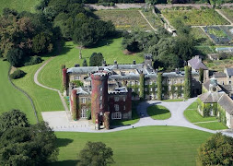

The first visit will take us north from Harewood to the Swinton Park Estate, to meet Dame Susan Cunliffe-Lister, head gardener of the 4 acre Walled Kitchen Gardens, which lie adjacent to the main house.

The Estate was originally laid out in 1760, following the English Landscape movement at that time, however the kitchen garden remained close to the House.
Since c. 2003 under Susan’s supervision, the Kitchen Garden is now one of the largest working and fully productive in England, where huge quantities of seasonal produce are used across the Estate and restaurant kitchens. There is also a cutting garden, flowers refreshed every Saturday throughout the Hotel.

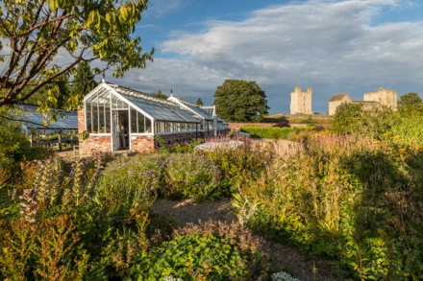

We will next travel across to Helmsley Walled Garden, was built in 1758 to provide fruit and vegetables to the Feversham family at Duncombe Park.
It gradually fell into decline like so many after two world wars, and was re-discovered in 1994 by Alison Ticehurst, who rescued the gardens bringing them back to production and to support therapeutic horticulture.
June Tainsh the Garden’s Executive Director, will meet us, along with some of the people involved today. Helmsley Walled Garden is a Charity run but its staff and Trustees, and many volunteers.

We will stop for lunch at Helmsley.

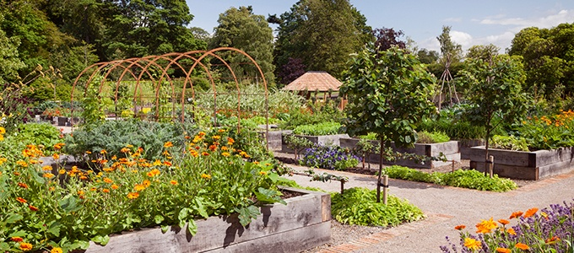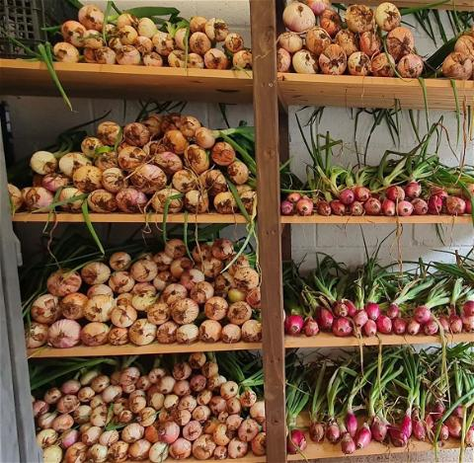
The Onion Store – June 2023

Our last visit of the day will be back in Harrogate at Rudding Park Hotel & Spa.

Set in 300 acres of Humphrey Repton designed landscape, and with a return to traditional ideals, the Kitchen Garden was designed by Matthew Wilson in 2014, sitting adjacent to the original walled garden of the Regency House and Head Gardener’s Cottage. It consists of 52 raised beds, made from English oak from the estate.
Here, Kitchen Gardener Emma Pugh grows between 450-500 different varieties of herbs, salads, vegetables, flowers and fruits organically, using No Dig principles. ALL the produce is used in the 3 Hotel restaurants and bar.

Emma and Sarah Owen-Hughes (Head Gardener) will be delighted to show us the kitchen garden, and hope to inspire and inform with novel suggestions for the crops they grow.
We will also have a dedicated room to round of the day, and make use of the bar!

We will add more information in the coming weeks and send maps out for attendees closer to the date

