Gordon Castle Walled Garden, Moray
and walled gardens of the National Trust for Scotland, Aberdeenshire

Restoration of walled kitchen gardens, in Scotland in the 21st Century

Friday 19th September: Walled Kitchen Gardens of the National Trust for Scotland

We begin this year with visits to three restored walled kitchen gardens of the National Trust for Scotland who, with Chris Wardle, gardens and landscape manager for Aberdeenshire, are very kindly hosting us

9.30am - Castle Fraser
- arrive from 9.00am for Registration

- meet at the walled garden for registration and an introduction to the day from Chris Wardle, before joining Ruth Wardle, head gardener, and the team

11.30am – Depart for Pitmeddon

12.00 midday - Pitmeddon

- we will have refreshments and lunch here, then meet Lewis Swales head gardener responsible for the gardens here and at Haddo House.

2.30pm depart for Fyvie Castle

3.00pm - Fyvie Castle

- Head gardener Gordon Thomson will introduce us to the garden, and we’ll have about 2 hours in the gardens.

The day will officially end at c. 5.00pm (tbc)

To finish the first day, we have booked a room at The Bank Cafe and Restaurant in Huntly, from 6pm, for an early supper. Not part of the paid event, but we’d love you to join us to unwind from the day.

Please note all timings for the day, apart from arrival and registration at Castle Fraser, may be subject to change.

Saturday 20th September: Gordon Castle Walled Garden

9:30am Arrive from 9-9.30 (tbc) at the Tower Room, Gordon Castle

10.00am - Welcome and Introduction to our host, Zara Gordon Lennox and speakers

10:10 – 12:30

- Chris Wardle
- National Trust for Scotland, the Trust’s work on garden restoration

- Nick Dunn VMH
- The art and craft of the espalier and importance in the restoration of kitchen gardens today

15 minute break and refreshments

- Maggie Tran
- Bringing productive gardens back to life on the Summer Isles - Tanera Mòr

- Zara Gordon Lennox
- Gordon Castle Walled Garden

1:00pm - lunch will be ready for us, a short walk away in the Walled Garden Café

2:00 - 4.00pm

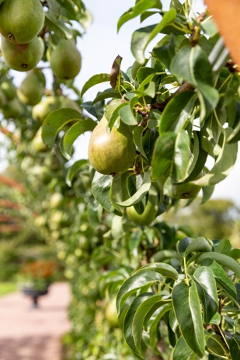
After lunch we will spend the rest of the afternoon in the Walled Gardens with Zara and head gardener Jennifer Wright, and her team

Celebrating World Day for the Art of Espalier

We are in planning for a final late afternoon visit to another private garden nearby. Details to follow.

After arrival at 9.30 in the Tower Room, all timings will be subject to change if required

