Gordon Castle Walled Garden, Moray
and walled gardens of the National Trust for Scotland, Aberdeenshire

Restoration of walled kitchen gardens, in Scotland in the 21st Century

Day 1 - Friday 19th September:

We begin this year with visits to three restored walled kitchen gardens of the National Trust for Scotland who, with Chris Wardle, gardens and landscape manager for Aberdeenshire, are very kindly hosting us

9.30am - Castle Fraser
- arrive from 9.00am for Registration

We will meet at the walled garden for registration and an introduction to the day from Chris Wardle, before joining Ruth Wardle, head gardener, and her team

11.30am – Depart for Pitmedden

12.00 Midday - Lunch in Cafe 48 at Pitmedden - soup and sandwiches in the Quarry Room

1.00 pm Pitmedden Garden

We’ll meet Lewis Swales, head gardener to hear about the gardens. Lewis has responsibility for the gardens here and at Haddo House.

2.30pm Depart for Fyvie Castle

3.00pm - Fyvie Castle

Head gardener Gordon Thomson will introduce us to the garden, and we’ll have about 2 hours in the gardens.

The day will officially end at c. 5.00pm

We have booked a room at The Bank Cafe & Restaurant in Huntly, from 6pm, for an early supper. Not part of the paid event, but we’d love you to join us to unwind from the day.
If you’d like to join us, let us know and we’ll send out the menu for pre-ordering.

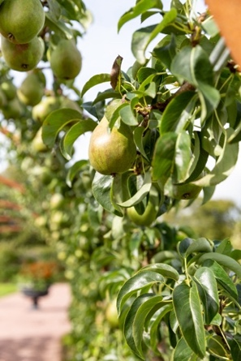
Day 2 - Saturday 20th September: Gordon Castle Walled Garden

9:30am Arrive from 9-9.30 at the Tower Room, Gordon Castle
(directions will be sent to attendees)

10.00am - Welcome and Introductions with our host, Zara Gordon Lennox

10:10 – 12:30

- 10.10 Chris Wardle
- National Trust for Scotland, the Trust’s work on garden restoration
- 10.45 Nick Dunn VMH
- Tree and top fruit production and cultivation

11.15 – a 15 minute break and refreshments

- 11.30 Maggie Tran
- Bringing productive gardens back to life on the Summer Isles - Tanera Mòr
- 12.00 Zara Gordon Lennox
- Gordon Castle Walled Garden

1:00pm - lunch will be ready for us, a short walk away in the Walled Garden Café

2:00 - 4.00pm

After lunch we will spend the afternoon in the Walled Gardens with Zara and head gardener Jennifer Wright, and their team

4.00pm we will depart the Gordon Castle Walled Garden for the Mayen Estate

From 4.30pm - Mayen Estate

To end the day and round off the Forum, we are invited for tea or cold refreshments on arrival, followed at c.6pm with a barbeque in the walled garden.

There will be time here to enjoy the gardens, relax and continue conversations and follow up questions before we formally close this year’s Forum.

Celebrating World Day for the Art of Espalier

