The 25th Anniversary of the Network
A celebration, and preparing for future decades

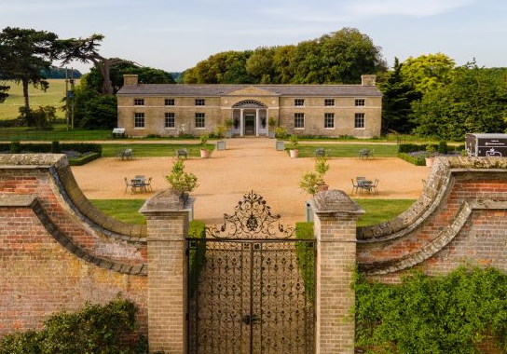
The Forum takes place on

Friday 9th October Holkham Hall and the walled garden
10:00am – 5:00pm, registration from 9:00am

Saturday 10th October visiting more walled gardens in Norfolk
10:00am - 4:00pm

Booking for both days: £160 Friday only £95 Saturday only: £65

Booking includes: talks, lunch & refreshments on both days, entry & tours of gardens.

Name:

Address:

Email: Telephone/mobile:

Organisation/Garden/other:

I/we would like to book …… place(s) for the WKGN Forum 2026

Both days: yes/no Friday only: yes/no Saturday only: yes/no

Please tell us your food preferences or allergies:

Send online BACS payment to:
Walled Kitchen Gardens Network Sort code: 20-53-22 Acct. no: 80691658

Please complete and return to: lucypitman@virginmedia.com or send to the address below.

For card payments and if you require an invoice / receipt please contact on the same email.

